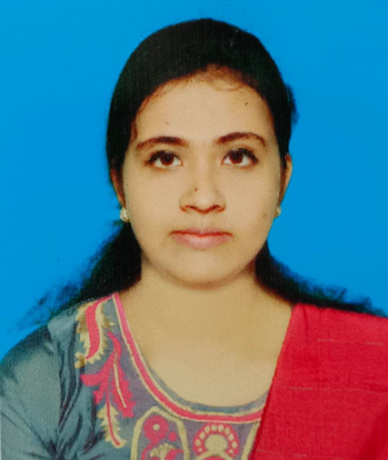
Ananya Kundu

+88001717071464
- ananyakundu032@gmail.com
Address
25/13 Tollabag, Sukrabad, Sher-E-Bangla Nagar Dhaka-1207

Career Objective:

To work in a challenging environment, achieve skills in the respective field and work for the simultaneous progression of organization and myself . To pursue a highly rewarding career, seeking for a job in challenging and healthy work environment where I can utilize my skills and knowledge efficiently for organizational growth. To work hard with full determination and dedication to achieve organizational as well as personal goals.

Key skills:

- Strives for learning and excellence
- Energetic, Dynamic and Challenging
- Strong desires to lead a life with dignity and sincerity
- Strong Communication and Interpersonal skills
- Aspiration to build a career showing superior performance
- Works well independently as well as in a team

Work Experience:

I have done some varsity C language Based Projects.
- Result Generator .
- Online Movies Ticket Booking System .

Achievement And Awards:

- Solved 100 problems in various online judges.
- Participated in Daffodil International University Take-Off Programming Contest 2021.

Technical Skills:

  - Programming Languages: C,HTML,CSS.
  - Version Control : Git , Github.
  - Office Tools: Microsoft Office 2013(Word, Powerpoint , MS Excel ) , Google Docs.
  - Operating System: Windows.

Education:

EDUCATIONAL INFORMATION

Name of the Exam. | Institution | Concentration/  Major | Result in CGPA | Year of passing
B.Sc | Daffodil International University | CSE | Running | ------
H.S.C | Joypurhat Govt. Women College ,Joypurhat. | Science | GPA 5 (Out of 4.83) | 2020
S.S.C | Panchbibi.N.M. Govt. Girls High School,Joypurhat. | Science | GPA 5 (Out of 4.78) | 2018

Language Proficiency:

Language | Reading | Writing | Speaking
Bangla | High | High | High
English | High | Medium | Medium

Personal Information :

Father's Name : Arun kundu .
Mother's Name : Shopna kundu .
Date of Birth : December 02, 2002.
Gender : Female .
Marital Status : Unmarried.
Nationality : Bangladeshi.
Religion : Hinduism.
Permanent Address : Village : Panchbibi
Post: Panchbibi , Thana:
Panchbibi ,
Dist: Joypurhat .
Current Location : Dhaka .



Signature:

